Understand Array Representation

How Arrays Are Represented in Memory:
- Arrays are stored contiguously in memory.
- Each element is accessed using an index, starting from 0.
- The address of any element can be found using: address = base_address + index * size_of_element
Advantages of Arrays:
- Fast access (O(1) time) to any element using an index.
- Memory-efficient for fixed-size data collections.
- Easy to implement for small, known-size datasets.

Analysis:
Operation | Time Complexity | Explanation
Add | O(1) | Adds at the end of the array
Search | O(n) | Linear search through the array
Traverse | O(n) | Visit each employee once
Delete | O(n) | Shifts elements after deletion

Limitations of Arrays
- Fixed Size:
  - You must define the size at the start.
  - Cannot grow dynamically.
- Complex Deletion/Insertion:
  - Requires shifting elements, which is O(n).

Code:
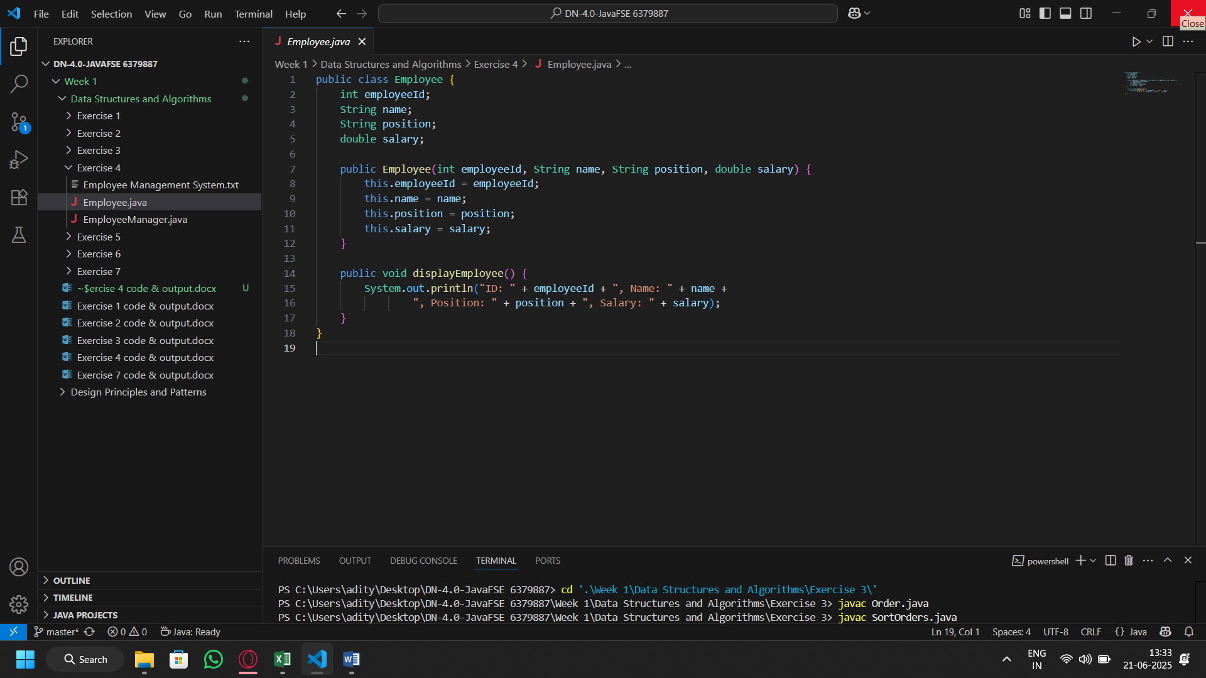
Employee Class

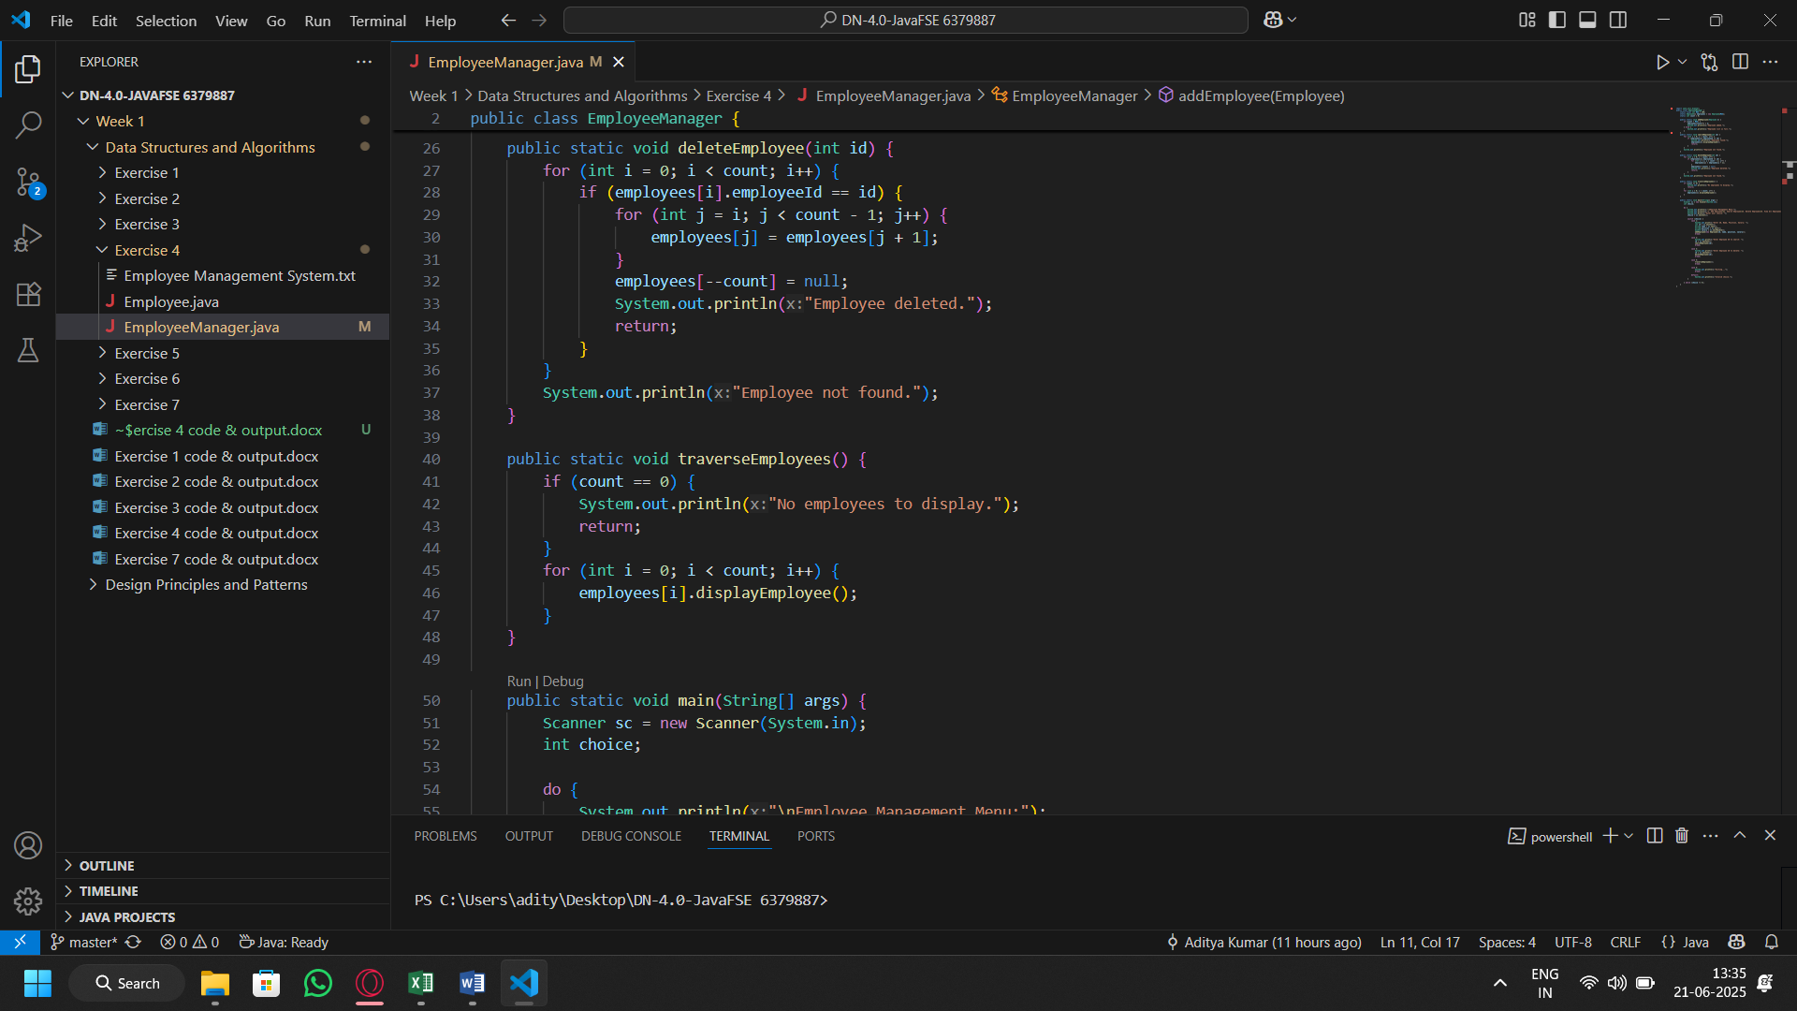
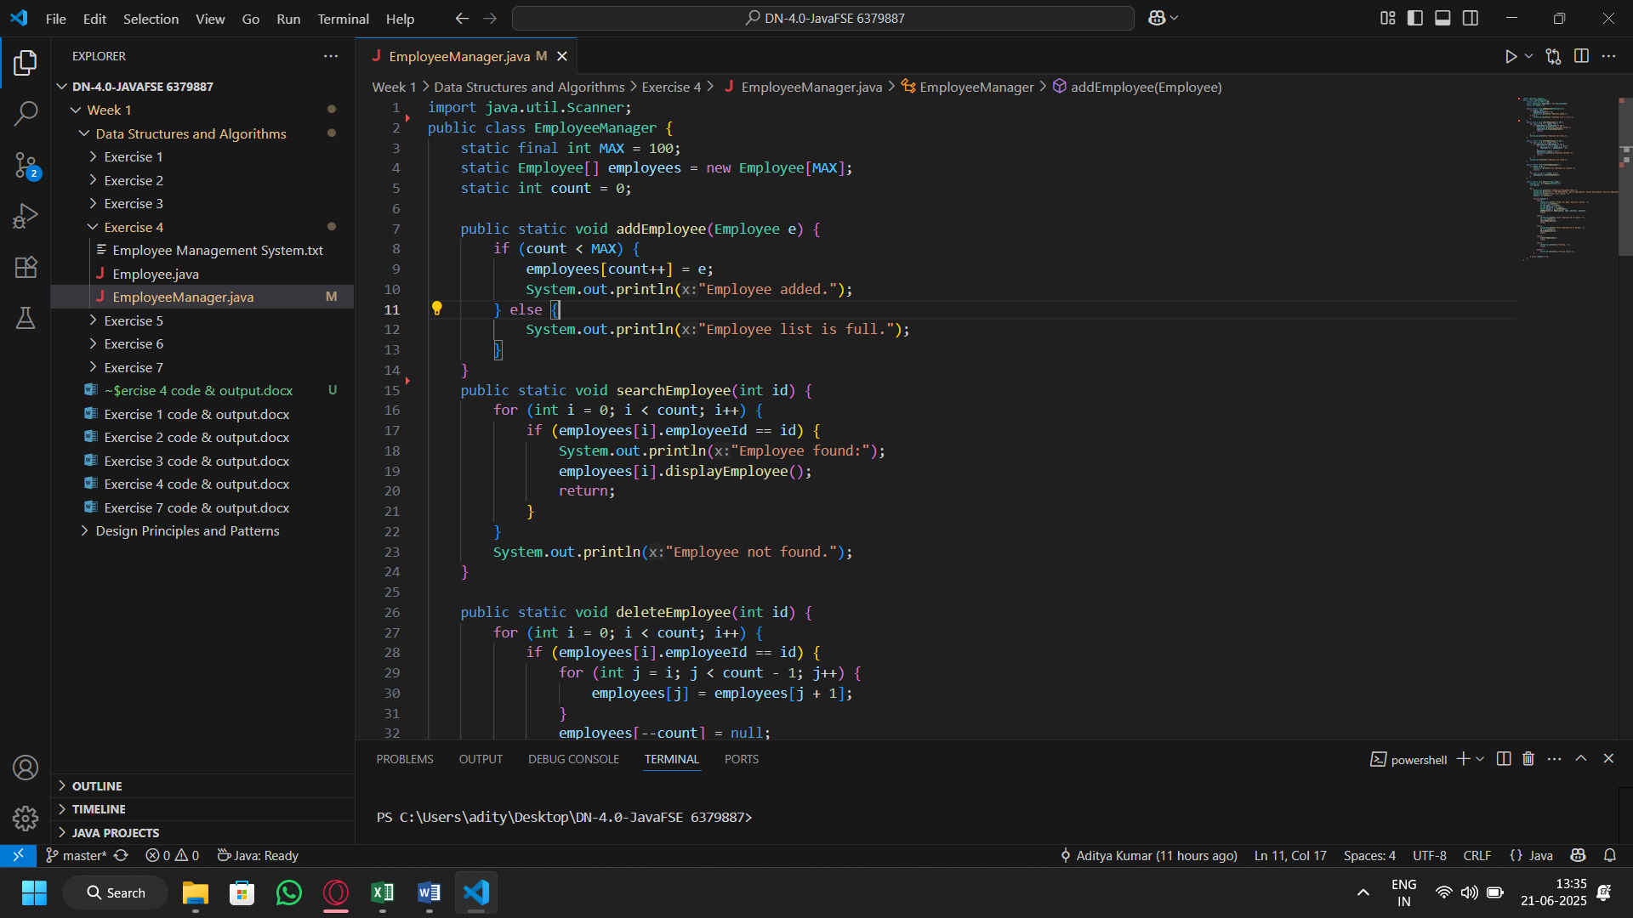
Employee Manager Class
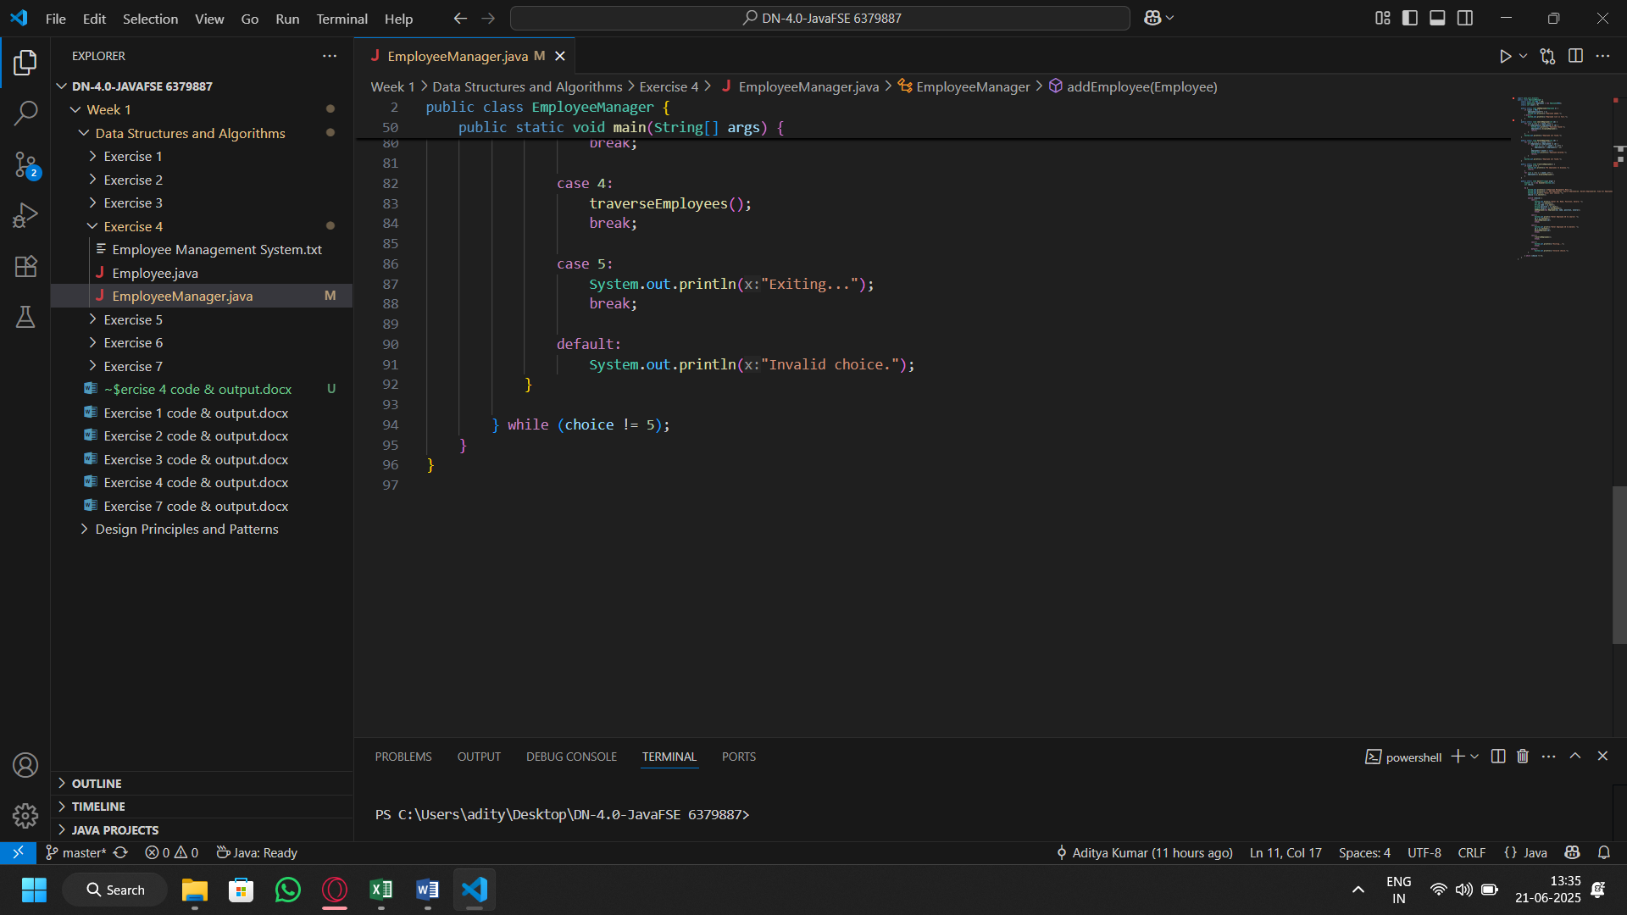
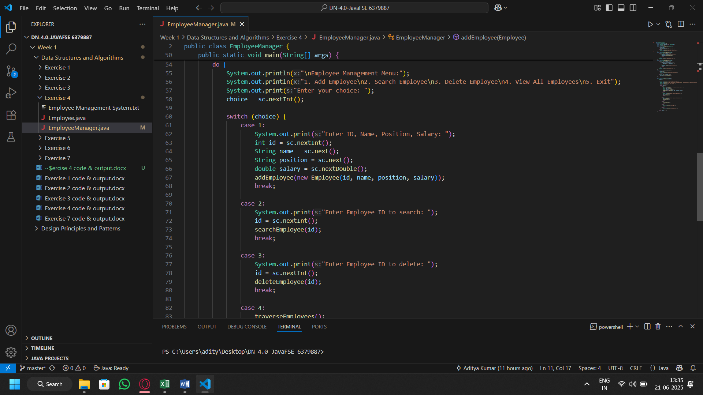

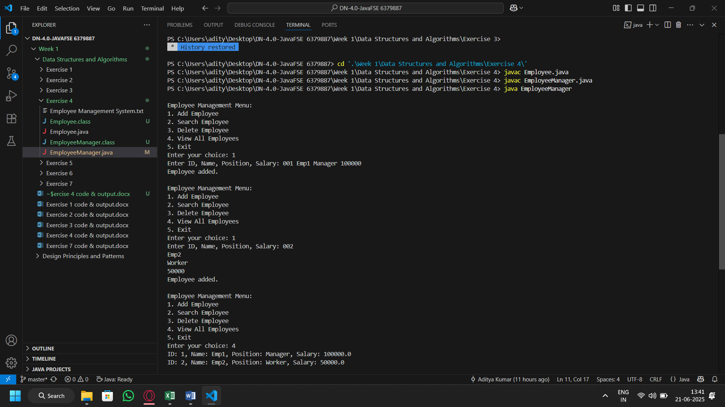
Output:

